EXPERIMENT 4
Data Modelling and Form Design for a Business Application in Zoho Creator

Aim
To design and build a “Vehicle Service Request Form” application in Zoho Creator using all thirteen Basic Fields of the Form Builder, enabling an automobile service centre to accept, schedule, and pre-record vehicle service and repair requests online.

Procedure
- Open Zoho Creator and create a new application named “Vehicle Service & Repair Request Management”.
- Add a new form to the application named Service_Request_Form.
- From the Basic Fields palette, drag and drop the required field types onto the form: Name, Email, Address, Phone, Single Line, Multi Line, Number, Date, Time, Drop Down, Radio, Multi Select, and Checkbox.
- Rename each field appropriately — Owner_Name, Email_Address, Pickup_Address, Contact_Number, Vehicle_Registration_Number, Issue_Description, Odometer_Reading, Preferred_Service_Date, Preferred_Dropoff_Time, Vehicle_Type, Service_Type, Additional_Services_Requested, and Authorize_Estimate_And_Repair.
- Open the Field Properties panel for each field and configure the required validations — Mandatory fields, email format check, phone country code, positive-only number range, and date restrictions.
- Review the Data Model in the App Builder to confirm that the Service_Request form and its linked Service_Report layer store every captured field correctly.
- Click Done to save the form, publish the application, and submit sample entries through the live preview.
- Open the Service_Request_Form Report to verify that the submitted records display correctly across all fields.

ER Model
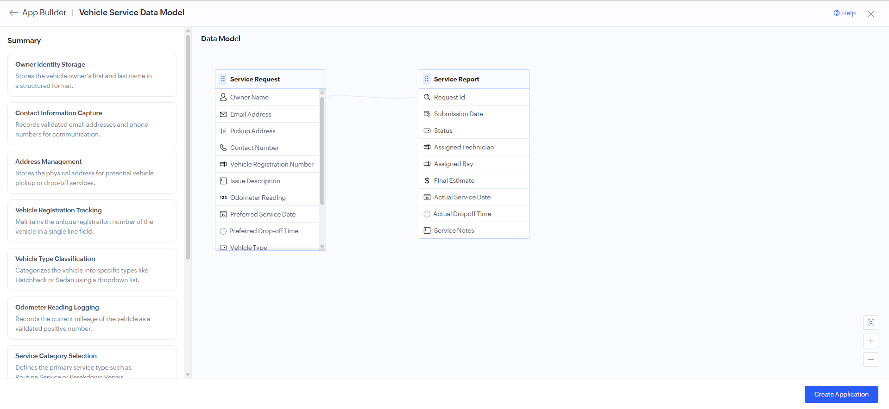
Data Model of the Vehicle Service Request application, showing the Service Request fields and the linked Service Report.
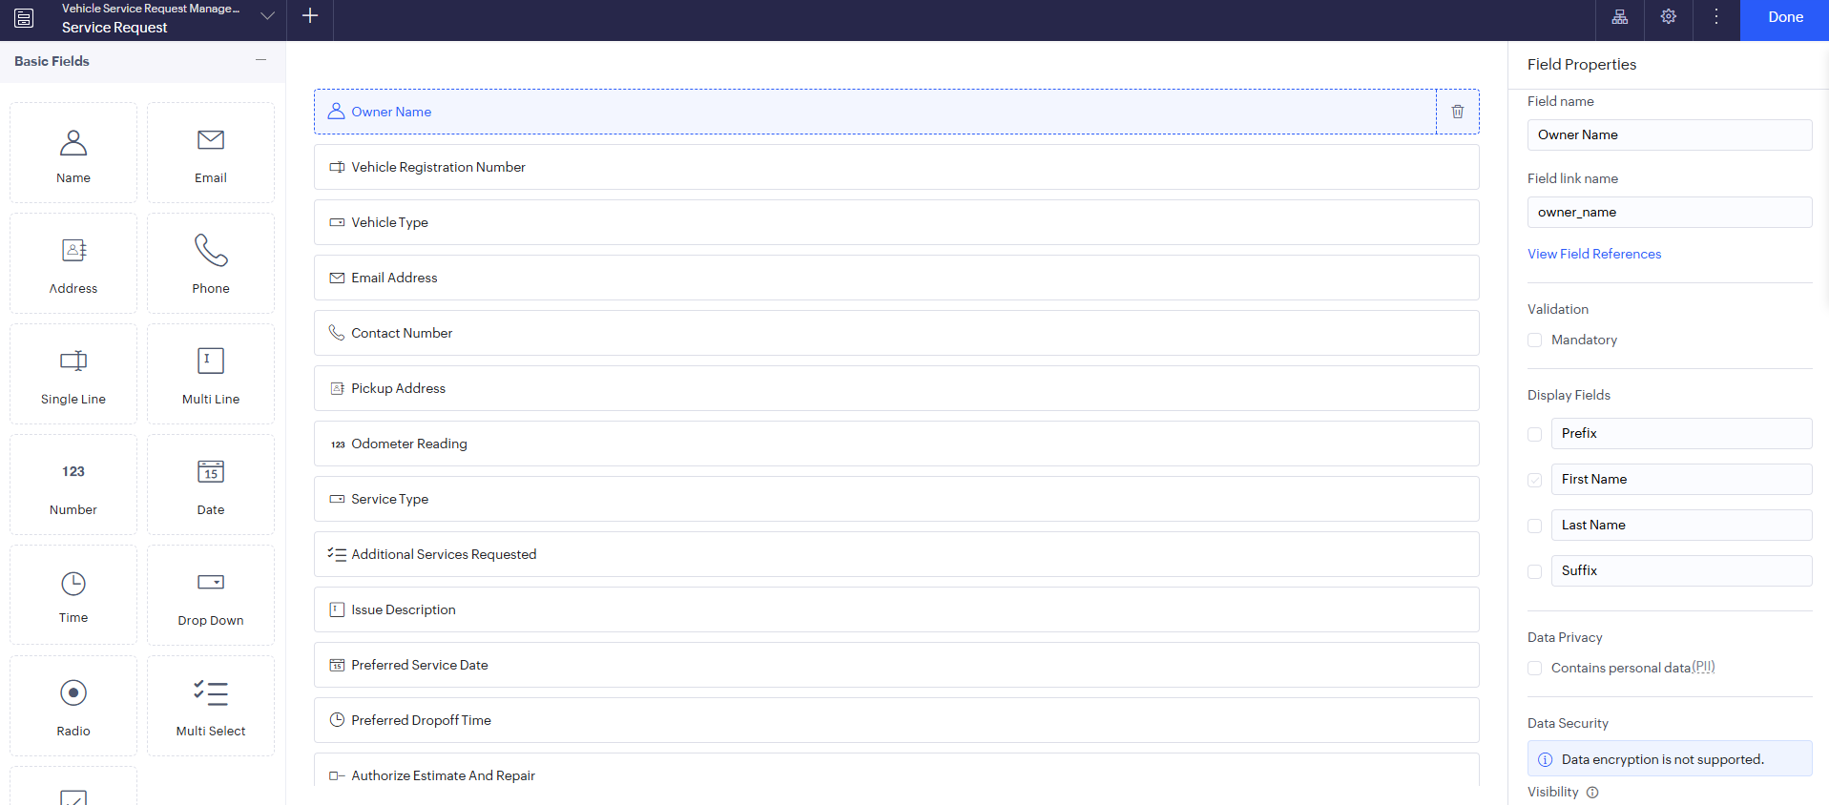
Form Builder view showing all thirteen Basic Fields configured for the Owner Name field with its properties.

Output
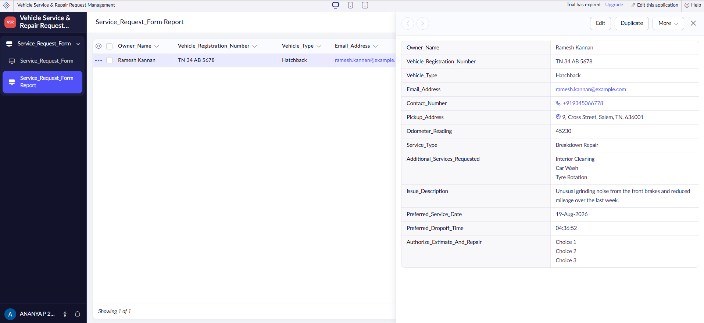
Service_Request_Form Report showing a submitted record with owner, vehicle, and scheduling details.

Result
The Vehicle Service Request Form application was successfully designed and implemented in Zoho Creator using all thirteen Basic Fields. The form captures owner, vehicle, issue, and scheduling details, validates mandatory and formatted inputs, and stores submitted requests in the Service_Request_Form Report, enabling the service centre to schedule vehicles and assign technicians in advance.

